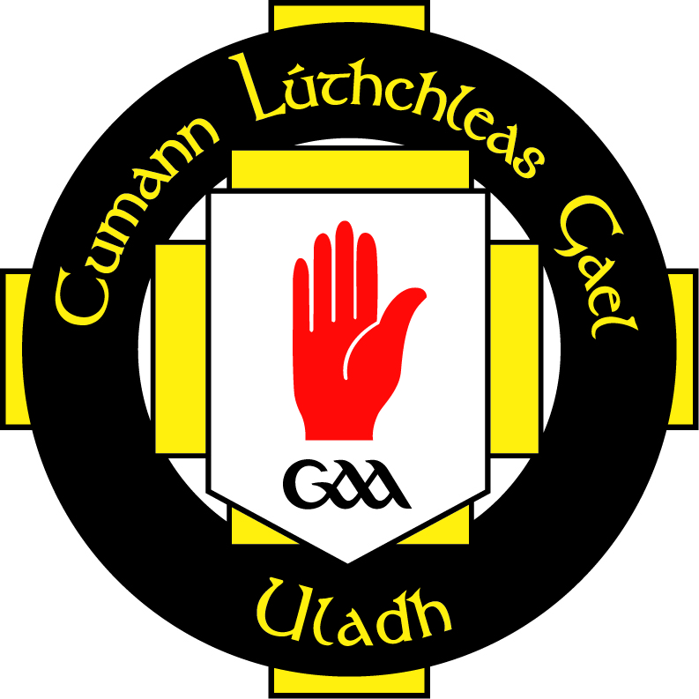
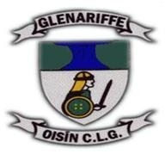

INSERT YOUR CLUB LOGO HERE

Data Protection Policy

Club Database Guidelines

The club complies with the requirements of the Data Protection Act 1998 with regard to the collection, storage, processing and disclosure of personal information and it is committed to upholding the Act’s core Data Protection Principals.

The club strives to ensure that it keeps a comprehensive data of all its members either on computer or otherwise. The club should ensure that it stores information on the following groups within the club:

Non-Playing Members
The information that should be stored on all non-playing members is as follows:
- Names
- Address
- DOB
- Occupation
- Home Tel Number
- Work Tel Number
- Mobile Number
- Special Medical Conditions

Players Members
There are separate tables set up for each of the different age groups within the club for both the male and female sections of the club (from U8 to Senior Level). This should be done for all codes player within the club (Male and Female Football, Hurling and Camogie).
The information that should be stored on all members is as follows:
- Names
- Address
- DOB
- School (if applicable)
- Occupation (if applicable)
- Home Tel Number
- Mobile Number
- Emergency Contact
- Special Medical Conditions
- Previous Sports Injuries
- Parents/Guardian name (if underage)

Club Officials
Information is stored on all club officials, both Executive Committee and all sub-committee members. The information stored is followed:
- Name
- Address
- DOB
- Occupation
- Role within club
- Home Tel Number
- Work Tel Number
- Mobile Number
- Special Medical Conditions
- Administration Courses Attended

Club Coaches
There is information stored on all coaches and volunteers, both actively coaching and no longer coaching within the club.

The information that should be stored on club coaches/volunteers is as follows:

- Name
- Address
- DOB
- Occupation
- Home Tel Number
- Work Tel Number
- Mobile Number
- Special Medical Conditions
- Actively Coaching?
- Team Coached
- Coaching Qualifications and Dates Achieved.
- Ulster Council and CPD Qualifications
- Child Protection Qualifications
- First Aid Qualifications
- Other relevant qualifications (and dates)

PHOTOGRAPH CONSENT FORM

Oisín CLG feel it is important to recognise the achievements and successes of our youth and of the Club as a whole. One of the ways to do this is to publish photographs and details of achievements in our local press. As a club we would like to use pictures of our youth members in the local press and at times, on the Club website.

We take the issue of child safety very seriously and this includes the images of the children in our care. Our duty to our young members is paramount and this form of publicity must be carefully monitored to ensure that it is consistent with our Child Protection Policy and the Data Protection Legislation.

For this reason we have put the following guidelines into place:

- We ask parental consent for the Club to take and use photographs of their children and for permission to use the press and media to promote the youth programme.
- Photographs and interviews will at all times take place in the presence of a coach.
- We will only use team photographs and action photographs on our website.
- Action and individual photographs will only be used, with individual parental consent, prior to the inclusion on the club website or in the local press.

I have read the conditions of use and consent to my child’s/children’s photograph being used. If there is any change to my decision I will inform the Club.

Name of child/children: ___________________________________________
___________________________________________
Name of parent/guardian: _________________________________________
Signature: __________________________ Date: ______________

Queries regarding this form should be addressed to:
The Child Protection Officer

