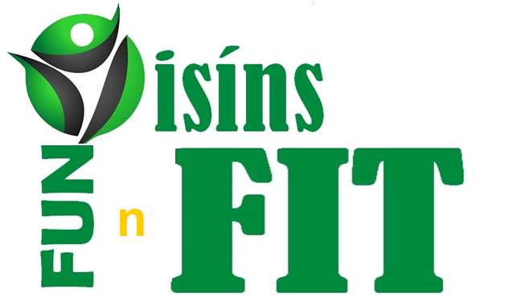  2016 |  | 2016
WEEK WEIGHT CHEST WAIST HIPS  1  2  3  4  5  6  7  8  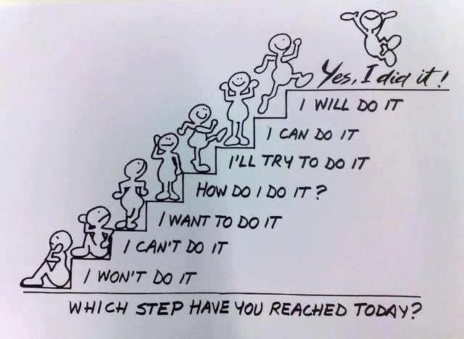 |  | WEEK WEIGHT CHEST WAIST HIPS  1  2  3  4  5  6  7  8
Date :  Breakfast  Snack  Lunch  Snack  Dinner  Date :  Breakfast  Snack  Lunch  Snack  Dinner |  | Date :  Breakfast  Snack  Lunch  Snack  Dinner  Date :  Breakfast  Snack  Lunch  Snack  Dinner
Date :  Breakfast  Snack  Lunch  Snack  Dinner  Date :  Breakfast  Snack  Lunch  Snack  Dinner |  | Date :  Breakfast  Snack  Lunch  Snack  Dinner  Date :  Breakfast  Snack  Lunch  Snack  Dinner
Date :  Breakfast  Snack  Lunch  Snack  Dinner  Date :  Breakfast  Snack  Lunch  Snack  Dinner |  | Date :  Breakfast  Snack  Lunch  Snack  Dinner  Date :  Breakfast  Snack  Lunch  Snack  Dinner
Date :  Breakfast  Snack  Lunch  Snack  Dinner  Date :  Breakfast  Snack  Lunch  Snack  Dinner |  | Date :  Breakfast  Snack  Lunch  Snack  Dinner  Date :  Breakfast  Snack  Lunch  Snack  Dinner
Date :  Breakfast  Snack  Lunch  Snack  Dinner  Date :  Breakfast  Snack  Lunch  Snack  Dinner |  | Date :  Breakfast  Snack  Lunch  Snack  Dinner  Date :  Breakfast  Snack  Lunch  Snack  Dinner
Date :  Breakfast  Snack  Lunch  Snack  Dinner  Date :  Breakfast  Snack  Lunch  Snack  Dinner |  | Date :  Breakfast  Snack  Lunch  Snack  Dinner  Date :  Breakfast  Snack  Lunch  Snack  Dinner
Date :  Breakfast  Snack  Lunch  Snack  Dinner  Date :  Breakfast  Snack  Lunch  Snack  Dinner |  | Date :  Breakfast  Snack  Lunch  Snack  Dinner  Date :  Breakfast  Snack  Lunch  Snack  Dinner
Date :  Breakfast  Snack  Lunch  Snack  Dinner  Date :  Breakfast  Snack  Lunch  Snack  Dinner |  | Date :  Breakfast  Snack  Lunch  Snack  Dinner  Date :  Breakfast  Snack  Lunch  Snack  Dinner
Date :  Breakfast  Snack  Lunch  Snack  Dinner  Date :  Breakfast  Snack  Lunch  Snack  Dinner |  | Date :  Breakfast  Snack  Lunch  Snack  Dinner  Date :  Breakfast  Snack  Lunch  Snack  Dinner
Date :  Breakfast  Snack  Lunch  Snack  Dinner  Date :  Breakfast  Snack  Lunch  Snack  Dinner |  | Date :  Breakfast  Snack  Lunch  Snack  Dinner  Date :  Breakfast  Snack  Lunch  Snack  Dinner
Date :  Breakfast  Snack  Lunch  Snack  Dinner  Date :  Breakfast  Snack  Lunch  Snack  Dinner |  | Date :  Breakfast  Snack  Lunch  Snack  Dinner  Date :  Breakfast  Snack  Lunch  Snack  Dinner
Date :  Breakfast  Snack  Lunch  Snack  Dinner  Date :  Breakfast  Snack  Lunch  Snack  Dinner |  | Date :  Breakfast  Snack  Lunch  Snack  Dinner  Date :  Breakfast  Snack  Lunch  Snack  Dinner
Date :  Breakfast  Snack  Lunch  Snack  Dinner  Date :  Breakfast  Snack  Lunch  Snack  Dinner |  | Date :  Breakfast  Snack  Lunch  Snack  Dinner  Date :  Breakfast  Snack  Lunch  Snack  Dinner
Date :  Breakfast  Snack  Lunch  Snack  Dinner  Date :  Breakfast  Snack  Lunch  Snack  Dinner |  | Date :  Breakfast  Snack  Lunch  Snack  Dinner  Date :  Breakfast  Snack  Lunch  Snack  Dinner
Date :  Breakfast  Snack  Lunch  Snack  Dinner  Date :  Breakfast  Snack  Lunch  Snack  Dinner |  | Date :  Breakfast  Snack  Lunch  Snack  Dinner  Date :  Breakfast  Snack  Lunch  Snack  Dinner
Date :  Breakfast  Snack  Lunch  Snack  Dinner  Date :  Breakfast  Snack  Lunch  Snack  Dinner |  | Date :  Breakfast  Snack  Lunch  Snack  Dinner  Date :  Breakfast  Snack  Lunch  Snack  Dinner
Date :  Breakfast  Snack  Lunch  Snack  Dinner  Date :  Breakfast  Snack  Lunch  Snack  Dinner |  | Date :  Breakfast  Snack  Lunch  Snack  Dinner  Date :  Breakfast  Snack  Lunch  Snack  Dinner
Date :  Breakfast  Snack  Lunch  Snack  Dinner  Date :  Breakfast  Snack  Lunch  Snack  Dinner |  | Date :  Breakfast  Snack  Lunch  Snack  Dinner  Date :  Breakfast  Snack  Lunch  Snack  Dinner
Date :  Breakfast  Snack  Lunch  Snack  Dinner  Date :  Breakfast  Snack  Lunch  Snack  Dinner |  | Date :  Breakfast  Snack  Lunch  Snack  Dinner  Date :  Breakfast  Snack  Lunch  Snack  Dinner
Date :  Breakfast  Snack  Lunch  Snack  Dinner  Date :  Breakfast  Snack  Lunch  Snack  Dinner |  | Date :  Breakfast  Snack  Lunch  Snack  Dinner  Date :  Breakfast  Snack  Lunch  Snack  Dinner
Date :  Breakfast  Snack  Lunch  Snack  Dinner  Date :  Breakfast  Snack  Lunch  Snack  Dinner |  | Date :  Breakfast  Snack  Lunch  Snack  Dinner  Date :  Breakfast  Snack  Lunch  Snack  Dinner
Date :  Breakfast  Snack  Lunch  Snack  Dinner  Date :  Breakfast  Snack  Lunch  Snack  Dinner |  | Date :  Breakfast  Snack  Lunch  Snack  Dinner  Date :  Breakfast  Snack  Lunch  Snack  Dinner
Date :  Breakfast  Snack  Lunch  Snack  Dinner  Date :  Breakfast  Snack  Lunch  Snack  Dinner |  | Date :  Breakfast  Snack  Lunch  Snack  Dinner  Date :  Breakfast  Snack  Lunch  Snack  Dinner
Date :  Breakfast  Snack  Lunch  Snack  Dinner  Date :  Breakfast  Snack  Lunch  Snack  Dinner |  | Date :  Breakfast  Snack  Lunch  Snack  Dinner  Date :  Breakfast  Snack  Lunch  Snack  Dinner
Name: ________________________________________  Team: ________________________________________  Mentors Details:  Name Tel No  Start Weight  Start Measurements  Chest  Waist  Hips  Start BP  Start Cholesterol  End Weight  End Measurements  Chest  Waist  Hips  End BP  End Cholesterol |  | Name: ________________________________________  Team: ________________________________________  Mentors Details:  Name Tel No  Start Weight  Start Measurements  Chest  Waist  Hips  Start BP  Start Cholesterol  End Weight  End Measurements  Chest  Waist  Hips  End BP  End Cholesterol

WK 1 |  | WK 1
Mood to Exercise |  | Mood to Exercise
Mood to Diet |  | Mood to Diet
Highs of the Week |  | Highs of the Week
Lows of the Week |  | Lows of the Week

WK 2 |  | WK 2
Mood to Exercise |  | Mood to Exercise
Mood to Diet |  | Mood to Diet
Highs of the Week |  | Highs of the Week
Lows of the Week |  | Lows of the Week

WK 3 |  | WK 3
Mood to Exercise |  | Mood to Exercise
Mood to Diet |  | Mood to Diet
Highs of the Week |  | Highs of the Week
Lows of the Week |  | Lows of the Week

WK 4 |  | WK 4
Mood to Exercise |  | Mood to Exercise
Mood to Diet |  | Mood to Diet
Highs of the Week |  | Highs of the Week
Lows of the Week |  | Lows of the Week

WK 5 |  | WK 5
Mood to Exercise |  | Mood to Exercise
Mood to Diet |  | Mood to Diet
Highs of the Week |  | Highs of the Week
Lows of the Week |  | Lows of the Week

WK 6 |  | WK 6
Mood to Exercise |  | Mood to Exercise
Mood to Diet |  | Mood to Diet
Highs of the Week |  | Highs of the Week
Lows of the Week |  | Lows of the Week

WK 7 |  |  |  | WK 7
Mood to Exercise |  |  |  | Mood to Exercise
Mood to Diet |  |  |  | Mood to Diet
Highs of the Week |  |  |  | Highs of the Week
Lows of the Week |  |  |  | Lows of the Week

