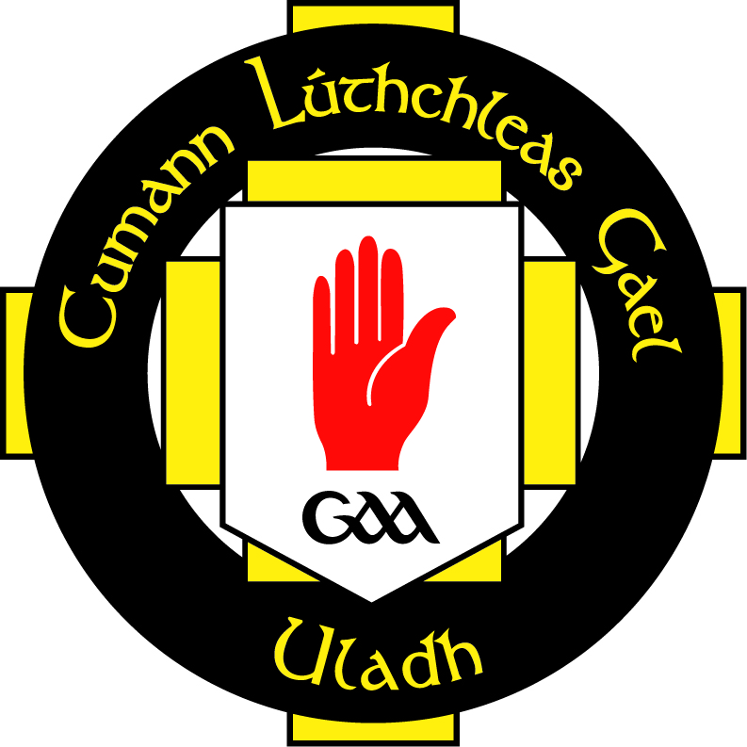

A Chara,

As part of the Comhairle Uladh C.L.G code of best practice in relation to child protection and to comply with current child protection legislations it has been decided to take the necessary steps to ensure that all personnel working with children i.e. under 18 within our counties and clubs must as part of our safe recruitment procedures be vetted.

In order to comply with the legislation under The Protection of Children and Vulnerable Adults (N.I.) Order 2003, the 2007 Safeguarding Vulnerable Groups (NI) Order and the The Protection of Freedoms Act 2012, it has been our policy from the 1st April 2008 to ask for the relevant check to be carried out by AccessNI. This check will enable Comhairle Uladh to ensure there is no known reason that should prevent those individuals from working with Children and/or Vulnerable Adults.

To ensure that everyone is satisfactorily and legally involved, it is necessary that all personnel working with Children and /Or Vulnerable Adults shall be classified as unsupervised and should apply as such.
All activity involving a Child And/or Vulnerable Adult will be deemed as training or coaching regardless of the specific role being undertaken by the individual insofar that they are directly accessible to Children and/or Vulnerable Adults.

The check will tell us: if you have a criminal record; if your name is included on the Disclosure and Barring Scheme (DBS) list of individuals barred from engaging in regulated activity with children; or if relevant the DBS list of individuals barred from engaging in regulated activity with adults; and any other information held by the authorities that may be relevant to the position applied for. Any information received will be treated confidentially and recruitment decisions will be made with discretion and will only have the involvement of the Comhairle Uladh case management group and will be treated with strict confidentiality. Should we need to speak to you regarding any information received we will do so without delay. A copy of your disclosure certificate will be returned directly by AccessNI to you and also to Comhairle Uladh.

In order for us to comply with the relevant legislation we request that the attached form is completed and returned via the Club nominated officer to Comhairle Uladh CLG, 8 – 10 Market Street, Armagh. BT61 7BX.

We would request that this matter be treated as a matter of urgency.

Is mise, le meas,

Bearni Ní Sionnaigh
Provincial Childrens’ Officer
Chomhairle Uladh

AccessNI Disclosure Certificate Application Form - Volunteers
Before completing this form if you wish to discuss any concerns you may have you can contact the Provincial Children’s officer.

Ulster GAA comply with the AccessNI Code of Practice as a Registered Umbrella Body with AccessNI and a copy of the code is available upon request to the Provincial Children’s Officer.

About this form.
Please complete this application form in CAPITAL LETTERS, using black ink. Applicants must complete Parts B,D,E,F and G and return to the Club Nominated Officer or the person who asked you to complete it.

Failure to complete the Form correctly may result in a delay or the form being returned unprocessed. There is no fee for checks on volunteers however if it is a position of paid employment or where exclusions apply as outlined by AccessNI (www.nidirect.gov.uk/accessni ) then a fee will be charged.

- Appropriate photocopies of Identity Documents should also be included with application. These will be destroyed by Comhairle Uladh once the form is checked for accuracy and only the AccessNI form itself is forwarded on to AccessNI.

- Completed applications must be returned to the Club Nominated Officer who will send to: the Provincial Children’s officer Comhairle Uladh CLG, 8-10 Market Street, Armagh, BT61 7BX, marked confidential

Name: _____________________________________________

Contact Number / Email: _____________________________

Club Name: ________________________________________

Position: ___________________________________________

Organisation: GAA Camogie Ladies Football Rounders Handball
(Please circle all codes that apply)

Is this a voluntary position? Yes No

Does the position involve working with:
(please tick)
Children Vulnerable Adults Both

The position you are applying for requires you to be engaged in regulated activity* as defined by the Safeguarding Vulnerable Groups Order (NI) 2007. Is there any reason you are aware of that would prevent you from working with children or vulnerable groups?

Yes No

*For further information on regulated activity, please contact Ulster GAA Children’s Officer (028) (048)37521900

Application check list.

- Have you completed all of sections B,D,E,F and G?
- Have you enclosed relevant photocopies of *identity documents as required?
* Documents must be verified by nominated person in club

Data Protection.
Information on this form will be treated in confidence. AccessNI is registered with the Information Commissioner and data supplied by you on this form will be processed in accordance with the provisions of the Data Protection Act 1998. The full protection statement is set out in section 1.10 of the Guide and can be accessed by visiting www.nidirect.gov.uk/accessni

The details provided on this Application Form may be referred by AccessNI to Government data sources specified in the Police Act 1997 (as amended) for matching purposes. Where a match is found data may be released to AccessNI for inclusion on the Disclosure Certificate. The details provided may also be used to update data source records where necessary, and they may also be used to confirm identity against external data sources using an electronic authentication product.

Office Use Only

_______________________________________________________________________________________________________________________________________________________________________________________________________________

Valid Identification Documents
Three documents must be produced in the name of the applicant; one from Group 1 and two from Group 2 (see below). If this is not possible, then four documents from Group 2 must be produced, one of which must be a birth certificate issued after the time of birth. It is preferred that at least one of these documents includes photographic identification.
Please use the form below and tick the appropriate boxes to indicate what ID has been submitted.
