Oisín CLG
secretary.oisins.antrim@gaa.ie
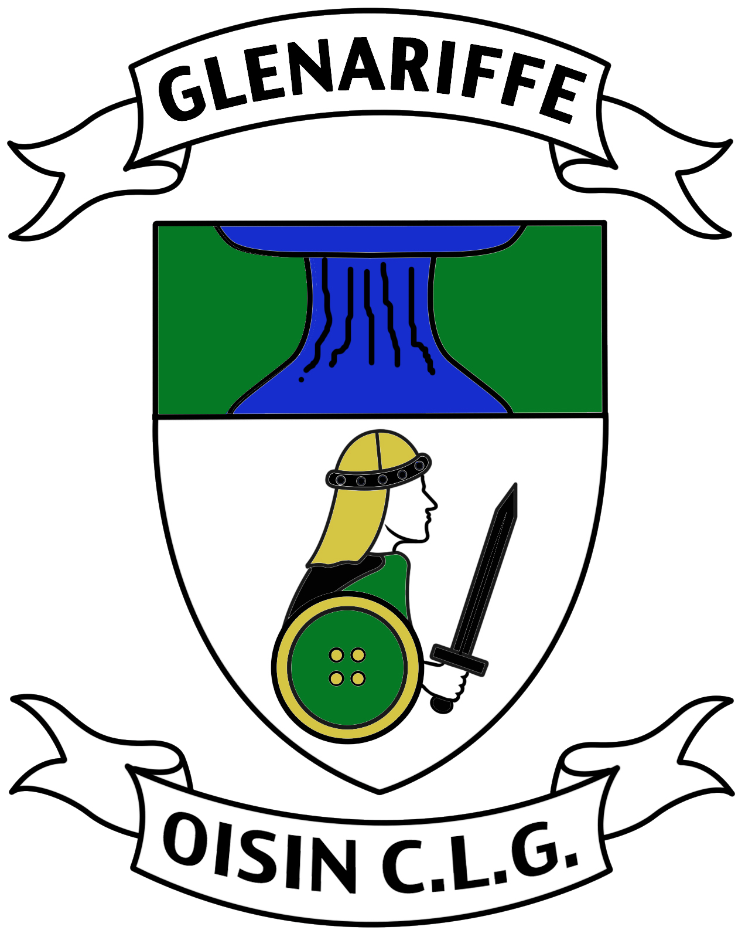
Tuarascáil an Rúnaí/Secretary’s Report 2013

Fáilte chuig Cruinniú Ginerálta Bliantúil dhá mhíle is a trí déag de Cumann Oisín Lúthcleas Gael agus go raibh maith agaibh as teacht.

Welcome to the Cumann Oisín Lúthchleas Gael 2013 Annual General Meeting and thank you all for coming.

Unfortunately the elected secretary felt unable to fulfil the role of secretary as a consequence Maggie McToal and myself took over the main secretary duties. Although Maggie McToal stood down as club secretary last year due to family commitments, she has remained very much a part of the administration of the club this year and agreed to take help in the drafting of this Secretary’s Report. The Secretary’s Report is a comprehensive report of club activities during the preceding year.

It is with pride that we congratulate Oisín CLG Glenariffe as one of the very few clubs across Antrim, in 2013, that committed to not only playing national games at all ages but also for actively supporting its’ Irish culture of traditional dancing, language, music and song by participating in Scór na nÓg and Scór Sinsir. The club’s participation has been recognised by many in the County and in the parish of Glenariffe and this can only assist in promoting a community spirit through the club and glen. We would thank the mentors Chrissie, Pauline, Therese and Maria and to all our juveniles who competed. We take this opportunity on behalf of Oisín CLG to extend best wishes to our Scór na nÓg Solo Singer Dearbhla McAllister who will be attending auditions for the Scór Encore television programme due to be televised by TG4 in early 2014. Ádh mór ort a Dhearbhla. Good Luck Dearbhla.

In the field of Gaelic games:

Girls Gaelic Football U8-U12 Team

Starting with the Girls Gaelic Football U8 – U12 teams. The girls, small in number, all from the Glenariffe parish, competed in monthly blitzes at different venues mainly in the South West area. They trained every Sunday morning thanks to their mentors Pauline, Helen and Kevin.

Girls Gaelic Football U14-U16 Team

The U14 & U16 Girls Gaelic Football teams have amalgamated with players joining from Cushendall and Glenravel. Both teams played in the South West League and performed well however disappointingly both teams were beaten by St. Bridget’s Belfast in the quarterfinals of The Championship. The U16 team won the South West Antrim blitz at the end of the season beating Moneyglass, Antrim, Ballymena and Aldergrove. It is envisaged that both the U14 & U16 teams should be strong going into the next season.

G4M Team
G4M has over 20 registered players who fought the elements training through wind, rain, hail and even snow on an occasion. They travelled to Dublin in October entering into the All Nationals with very successful results winning all five matches and have to be congratulated. The team train once a week for a few hours enduring a lot of gruelling circuits from their mentors Martin McKendry and Brendan Healy and without them success would not have been possible. The mothers have found a common bond with other mothers in our small community and have come together and formed many new friendships. G4M gives the girls a great source of escapism, exercise and community spirit. G4M are all looking forward to a new season in March 2014 introducing new players, members and friends.

U6/U8/U10 Hurling Teams

Another excellent season from our U6/U8/U10 Hurling Teams and also a very enjoyable one. Training began in January for these teams, with indoor training in Garron Tower, and continued to the end of September. A full nine months hurling for these players which requires great commitment not only from the players but also from their mentors, and we are seeing the rewards from this effort with performances on the field and the numbers who are turning up for training.
U6 - It is very difficult to arrange matches for this age group as some clubs do not have teams at this age group. However we had a number of outings against Glenarm, Cushendall, Ballycastle and Loughgeil and the boys and girls went undefeated for the whole season.
U8 & U10 - At this age group we have a blitz every Sunday at a different North Antrim club which was co-ordinated by ourselves and McQuillans Ballycastle club. We were the only club to take two teams to every blitz, which was a deliberate decision by the mentors as it was more important to us to get as much game time as possible for our players rather than winning at all costs.
At U8 we have an excellent group of players who remained undefeated all season beating all North Antrim clubs and if possible next year we should look to play more clubs from outside North Antrim to develop these players further. This was a tremendous achievement by this group of players as they probably had 20 to 25 matches throughout the season.
Our U10s had a great year which was set up by getting to the Ulster U10 Division 1 final in February where we were narrowly defeated by Ballycastle, a defeat that we would avenge on a number of occasions later in the year. We also had 2 teams in this competition, which requires a big commitment from mentors as you are in different venues on the same day.
We also entered another Ulster indoor competition in Magherafelt with one team not losing any games and winning their section, and the other one losing in the final of their section. But great experience for the boys to travel and play in another new venue.
In July we won the U10 Centenary Cup in Dunloy with a convincing win over Loughgiel and continued this form into the U10 Championship in September. Again we fielded two teams in the U10 Championship blitz with some clubs deciding to only take one team giving games to their 12 best players. On the day our B team got to the final of the U10 B Championship and lost to St Enda's from a last minute goal. What was great about this group is that they were mostly made up of U8 players. Our A team lost in the semi-final of the A Championship probably as a result of tiredness as we had to play Cushendall in a play off to make the semi final. This extra game really did take it out of the boys. Loughgiel went on to win The Championship on the day but they did not defeat Oisín as we drew in the earlier rounds.
In the P7a Championship in October we lost in the semi final to the eventual winners Loughgiel. We actually didn't lose as we were level at the end of the game and went out as a result of Loughgiel having more wides.
We can be extremely proud of all our young juveniles as we are consistently competing with all the so-called big clubs and teaching our players not to fear playing any of them. They are a credit to the club. The future looks good thanks to our enthusiastic mentors and coaches.

U12 Team

2013 was a very strong year for our U12 team. They started the year by getting to the finals of both the North Antrim Division 1 indoor and North Antrim Division 1 indoor Airbourne competitions. They won the All County Division 2 League, winning all their matches. They won the North Antrim B Championship, defeating St Brendans in the Final. Eight of our Under 12 players were also on the St Killians Garron Tower team that played in the Final of McNamee Cup, and 3 of our players have been picked for the Antrim U14 panel for the incoming season. We had a very strong panel of 22 players, who worked very hard all year and who deserved all the success they had this year.

U14 Team

A surprisingly strong year for our under 14 team as we had a very small panel of 16 players, 10 of which were under 12. They won the All County Division 2 League, losing only one match. They also got to the North Antrim Féile final, but unfortunately due to an injury to one player and a very contentious suspension to another player, we could not field 15 players, and had to concede the final. All the players deserve great praise for their fantastic commitment this year with virtually 100% turnout for every training session and every match. We had two players on the Antrim U14 team this year, with Shane O’Connor being picked as captain, and lead them to the semi final of the Tony Forristal All Ireland competition in Waterford where they were narrowly beaten by Clare.

U16 Team

There were only 15 players in this year’s U-16 team. Due to injuries and sickness on occasion this made it difficult to field a team. Despite this the team reached the Championship semi-final. With a larger squad coming through next year we have every confidence in them going one better.

Minor Team

The Minor team had a very successful year. They were joint All County Minor B League Winners. They were beaten finalists to Dunloy in the All County B Championship to a team coached by this year’s All Ireland Winners Hurling Manager Davy Fitzgerald. A number of the Minor team trained and played for the Oisín Senior Team in All County Division 1 League and Senior Championship and have been instrumental in the wins against a number of County Senior Players. The Minor team players are committed to winter conditioning and no doubt will continue to compliment the Senior Team in 2014. You should all be very proud of your loyalty to the club and your mentors. Well Done Boys!

Junior Team

Our Junior Hurling Team struggled with numbers this year however fulfilled all their fixtures. Hopefully with U16 players coming through the ranks The Junior Team numbers will increase next season.

Senior Team

As agreed with The Senior Team’s Manager, Martin Coulter, this year was a very difficult season for the Senior Hurling Team and for all concerned. Firstly we were stepping up to the first division and due to retirements and immigration we were forced to do this while trying to rebuild the majority of the team. This was also Martin’s first season in charge of the team and so it took him a period of time to look at and assess all the players available and for the players to get used to him.

It is fair to say we had our fair share of bad days this year, The Championship performance in particular still hurts, however we still were very unlucky to be relegated on goal difference and some of the performances at home gave us great heart for the future.

Martin strongly believes that 2014 will see a much improved Glenariffe Senior Hurling Team. There is a committed group of experienced players and a very exciting group of lads from between the ages of 18-20 yrs who are already making a big effort in the gym to try and make their way onto The Senior Team. These lads will be the future of the club.

Martin reports that he cannot fault the endeavour and commitment of all the lads and this season they can make a serious push towards winning both The League and Intermediate Championship…and beyond.

We would like to thank sincerely all the club mentors for assisting with these reports.

Friends of Glenariffe

The FOG curtailed their events due to the financial climate, to the Marquee 2013, which gave the group a profit of £12,000. Balance at present is £153,000. Planning was submitted for the entire project as it was felt that with the Parochial Hall closed the FOG would be in a better position of securing funding for the project as a whole rather than 2 separate phases. Because of the new size of the project the DOE require us to have 90 metre sight lines exiting the field. FOG has agreement from Mr Jim Colligan and Mrs Geraldine Meeke to the easement and this is currently being dealt with our solicitor.

FOG has submitted applications for funding with:

- SIF – Social Investment Fund, which is funding from the First Ministers Department – 100% funding – the project has been recommended.

- Spaces & Places, which is funded by the National Lottery - £600,000.

FOG has applied for smaller grants for a PA system for the club.

FOG has secured a grant for £5,500 for a feasibility study for the project.

FOG is currently working with North Antrim Community Network who are in the process of sourcing grants and training on our behalf.

Thanks to FOG Chairperson Myra Murray for this report.

To continue with club matters:

We cannot forget the help that we get from our local schools - St. Patrick’s Primary and St. Killians and from Cathal Gerard McNaughton who is our School Link Liaison Officer. Cathal Gerard visits our primary school faithfully every Tuesday to coach hurling. His help is invaluable to the club having a knock on effect on the juvenile’s successes in club blitzes and tournaments. Two other coaches also visit the school – Sambo as we know him and a coach from Ulster Colleges. Sambo’s words this year have been noted that ‘Oisin CLG have the best run juvenile set-up’ that he has seen. We personally thank our juvenile mentors for their loyalty and dedication. Your efforts are reaping the rewards. The club is proud of you all. We may one day win a Senior Championship!

Our juveniles are important to us and as a club we have a responsibility to protect our children. Juvenile Mentors and all coaches are required to have Child Protection Certificates. We ask everyone working with children to make certain that they are adequately covered. As well as it is a club responsibility it is also an individual responsibility.

We are conscious of our duties of the health and welfare of members and supporters and to that end promoted the following in 2013:

- Child Protection Course.
- Conor McCafferty from ZEST held a Talk on Emotional Health, Alcohol and Drugs Abuse.
- Posted health related leaflets regarding drugs, alcohol and mental health concerns on cars at Masses and in kit bags from U16 to senior level.
- Hosted The Farm Families Health Check Van on Marquee weekend.
- Held fundraising event for NI Hospice collecting gate proceeds of £305.00 on Sunday 14th July.
- Coaching Courses held throughout the year. It was a pleasure to see seven young Minor players attending recently.
- Trips to Croke Park to watch All Ireland Girls Gaelic Football Finals and All Ireland Hurling Semi Finals.
- Trip to Rathlin Island to compete in The Sciath na nóg Shield

We would like to thank Brenda Carey and Joanne Kerr from St. Patrick’s Primary School and Padraig McIlwaine from St. Killians who facilitated the different club events over the year.

To assist with club expenses fundraising events took place in 2013 - The weekly lottery, cake and bun sales, sponsorship of pitch side banners and the Friday night quiz held in The Mariners during summer. This event was mainly supported by ‘the caravaners’ and we thank them for their continued support each year. We cannot forget the introduction of the co-ordinated training tops and track suit tops from U8 to Senior level. Special thanks to Sponsors: Alex Mc Mullan, Synergy Learning, Eddie Haughey and Oisín Woodworking New York.

Our Club Maith application it has not been forgotten about and there are still some outstanding elements that require completion. It would be great for the status of our club if we were in a position to submit our application and be successful but it requires a lot of hours. Hopefully 2014 will see its completion.

As regards public relations, we thank Michelle O’Toole our PRO for her work during 2013. We encourage members to provide, stories, pictures, feedback and information to help the PRO promote the club. Match reports are priceless for individuals and parents and would be welcomed. Like many roles in the club all work cannot be left to one person alone. Our ability relies on more people getting involved at ground-level. We extend our sincere thanks also to our outgoing Juvenile Secretary & Child Protection Officer Monica O’Neill for her hard work during 2013.

Oisín CLG is a busy and vibrant club but it is a matter of great concern that we lost officers during 2013. This places a heavy burden on the club executive and the situation must be resolved for the coming 2014 season. In addition it was disappointing to the club executive that there was poor attendance at monthly club meetings. The modern GAA expects high standards from clubs and we need to challenge ourselves to think differently to find new ways of working together. We trust and hope that the club can achieve this in 2014. We can confirm that training and workshops for new club officers will take place in January 2014 as arranged by Ulster GAA.

We thank all the committee members, club officers, sub committees, team mentors, referees, club delegates, the primary school, staff in St. Killians, Mairead Douthart and Fr. White for their assistance and support during 2014.

Regarding the Fixtures Secretary for The Senior Team we thank Martin Coulter and Maggie McToal for the many telephone calls made regarding fixtures and those never ending dreaded re fixes. Thankfully both sang out of the same hymnbook – supporting and protecting The Senior Team. Maggie McToal indicated it was a pleasure working with Martin and would want to thank him for his help and courtesy to her and the opposing clubs during 2013.

With respect to the club’s participation in Scór, promoting different aspects of our culture, this would not have been possible without the guidance of our Cultural Officer Mairead McMullan using her knowledge of Irish History and fluency in Irish Language. It is an honour to have Mairead in the club and was a pleasure this year to host our 51st Feis na nGleann in Glenariffe, the home of The Feis, alongside Mairead. Hopefully we will be hosting our 52nd in 2014! Go raibh míle maith agat Mairead as an chuidiú agus an tacaíocht a thug tú dom sa bhliain dhá mhíle is a trí déag.

We are indebted to Hugh and Margaret McIlwaine for the endless support they gave with admin duties in 2013. Hugh and Margaret are in many ways the heart of the club and a good club will only function well having hard working individuals and our club is blessed to have them both. Hugh and Margaret McIlwaine’s commitment to the club is invaluable.

The duties of the secretary merge with those of The Chairman and it is essential that both work as a team. As we know this is Niall’s last year in office and we will genuinely miss him as the principal officer, The Club Chairman. We extend our sincere thanks to Niall for his leadership support and wealth of experience and knowledge of all things GAA shown to all officers and members of Oisín CLG. We wish to thank Niall for his years of commitment and dedication to Oisín CLG and have no doubt that he will continue to offer his assistance from a distance. We thank him for seeing the club through good times and bad. Niall you deserve a rest from the role of Chairman, a position that requires bravery and dedication. Your service to Oisín CLG Glenariffe, ‘The Friends of Glenariffe’ and The GAA in general was invaluable. May you enjoy your free time with Kathryn, your grand children and your family.
As a mark of respect to Niall the committee feels that we should offer Niall the Presidency of the club considering his years of commitment and loyalty to Oisín CLG.

Agus chun chrióchnú, gúim gach rath ar bhainisteoireacht, ar choistí, agus ar fhorine i nda mhíle is a ceathair déag.

And finally we wish our management, committees and teams success in 2014.

Go raibh míle maith agaibh

Maggie McToal + Kenny McCormack

8ú Nollaig 2013

