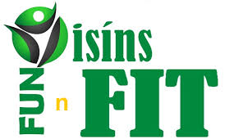

Glenariffe Oisin CLG Fun n' Fit - Talks on Wellbeing

As part of the club’s health and well being initiative, the following talks have been arranged to take place in St Patrick’s Primary School, Waterfoot.
The talks for children age 12 - 16 years will require parental/guardian permission (See panel below).

Practical Assistance & Support 16th March - 7.30pm
SVP - Archie Kinney & Maria Fyffe

Dementia Awareness 23rd March - 7.30pm
Alzheimer’s Society - Valerie Cuthrie

Cross Community - 12- 16 year olds 30th March - 7.30pm
Corrymeela
(Parental consent required)

Wellbeing of Older People 6th April - 7.30pm
NIAMH - Alex McKeown

Alcohol awareness - 12- 16 year olds 10th April - 7.30pm
NHSCT - Sandra Ramsey
(Parental consent required)
I give permission for................................................................(name of child) to attend the

..........................................................................................................(name of event(s).

Signed........................................... Date.....................................

Please complete and take to event

