OISÍN CLG
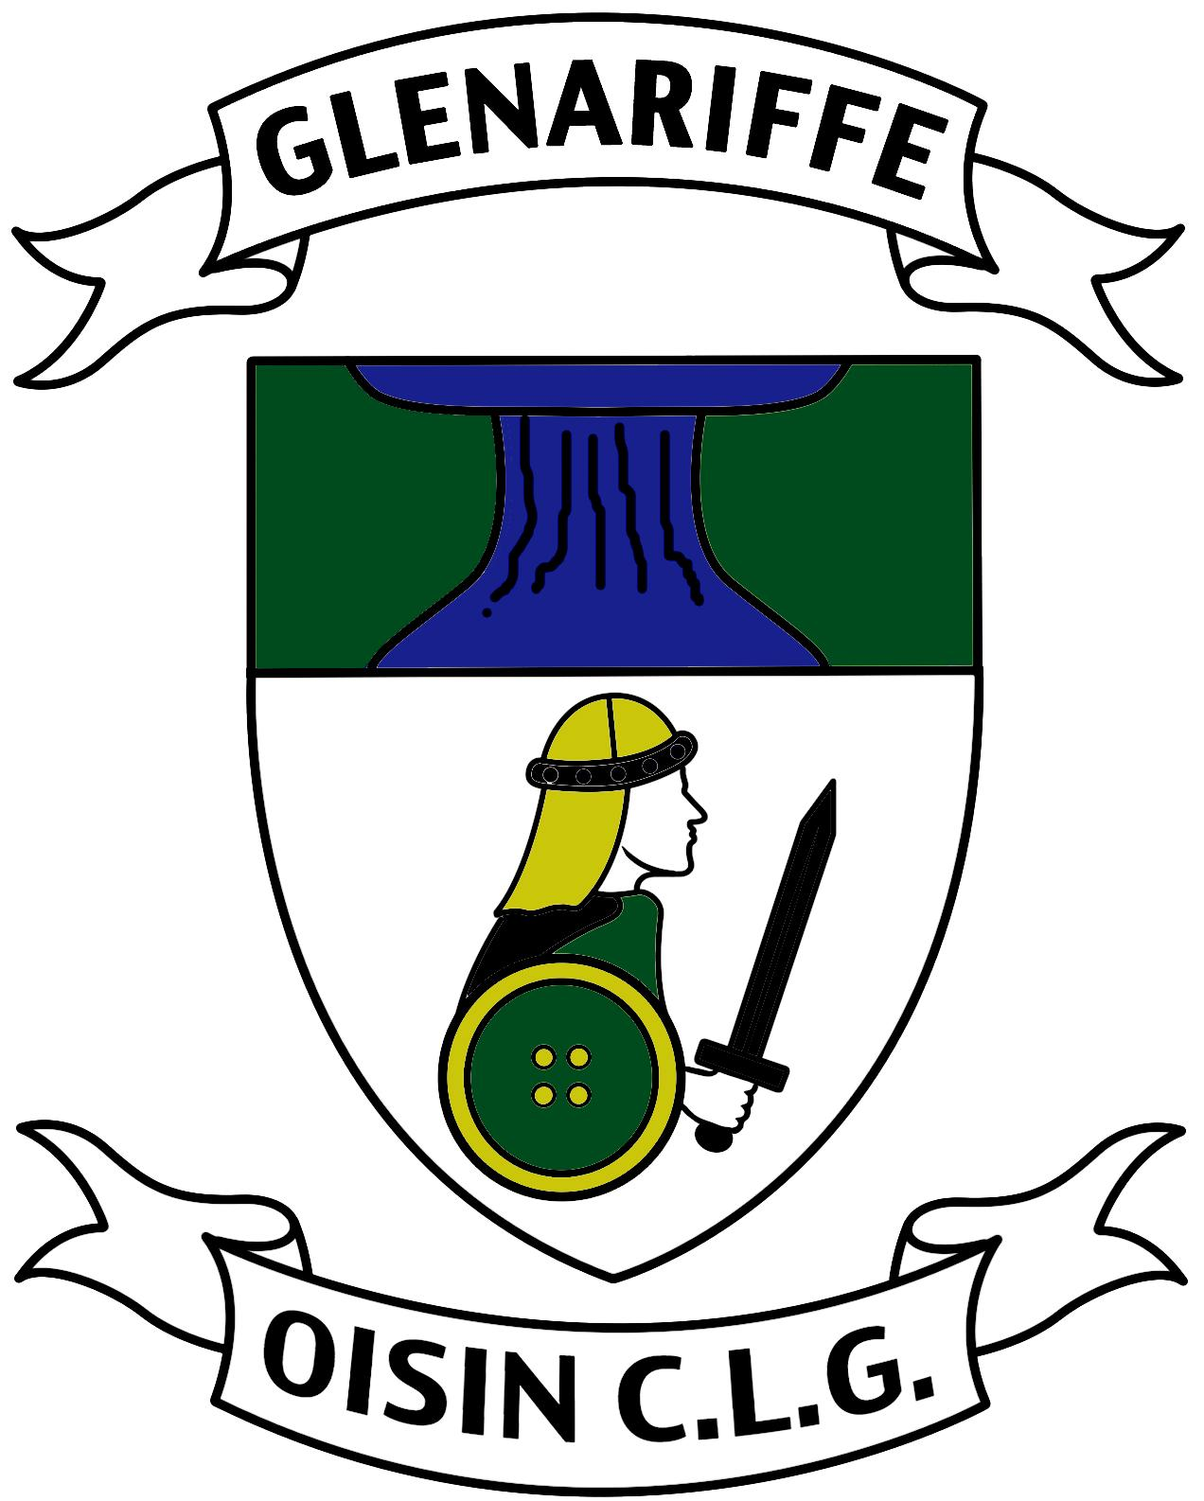
Bunaíodh 1904

Annual General Meeting 2017

OISÍN C.L.G.

CRUINNIÚ GINEARÁLTA BLIANTÚIL / ANNUAL GENERAL MEETING

19 ú Samhna 2017 /19th November 2017

CLÁR/Programme

- Paidreacha ar son na baill atá marbh/ Prayer for deceased members.

2. Mionntuair don Chruinniú Ginerálta Bliantúil roimhe/
Minutes of previous AGM. – Appendix A.

3. Tuarascáil an Rúnai/Secretary’s report Appendix B.

4. Tuarascáil an Chisteora/Treasurer’s report – issued at meeting.

5. Tuarascáil an Peil Ghaelach na mBan/ Ladies Gaelic Football report. Verbal.

6. Tuarascáil an Rúnaí Óg/ Juvenile Secretary report.Verbal.

7. Óráid an Chathaoirligh/Chairman’s address.

8. Toghchán Oifigigh/Election of officers Appendix C. All require to be proposed and seconded.

9. Molta / Recommendations – all require to be seconded.

- That the club opts to hold its property through the Corporate Trustee. Proposed by the club secretary.
- That the club adopts and operates within the One Club Guidelines Broad Framework which was published on 17 June 2017.Proposed by the club secretary.

10. Gnó eile / other business.

- Friends of Glenariffe Community Hub Project.

