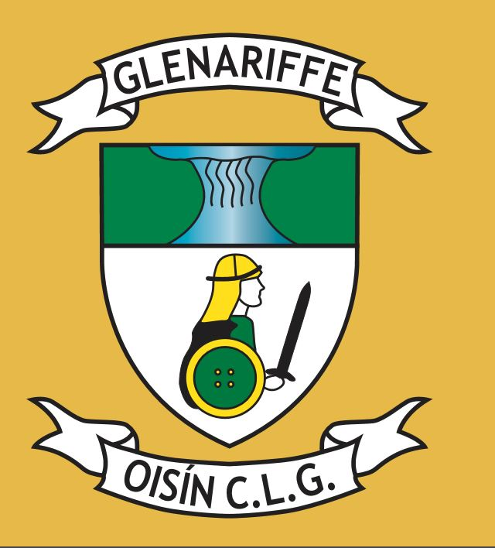
Notice of AGM 2018

The Annual General Meeting 2018 of Glenariffe Oisín CLG will take place at 3.00pm on Sunday 25 November 2018 in The Mariners Waterfoot. Any motions/recommendations and all nominations to fill the posts detailed below are now invited from fully paid up club members. Motions/ recommendations and any nominations to fill the posts detailed below, all which must have a proposer and seconder, should be submitted to the club secretary no later than 11 November 2018 so that an agenda can be issued at least 10 daysin advance of the meeting. Only fully paid up members can attend and vote at this meeting.

President | Chairman | Vice Chairman | Secretary | Assistant Secretary
Treasurer | AssistantTreasurer | Public Relations Officer | Chairman  Juvenile Committee | Club Registrar
Child Protection Officer - female | Child Protection Officer-male | Cultural Officer | Alcohol & Substance Abuse Prevention Officer | Health & Wellbeing Officer
Delegate to County | 1st Delegate to North Antrim | 2nd Delegate to North Antrim | Grounds Person | Assistant Grounds Person
Coaching Officer | Ladies Gaelic Football Manager | Senior Hurling Manager(s) | Junior Hurling Manager | Minor Hurling Manager
U16 Hurling Manager | U14 Hurling Manager | U12 Hurling Manager | U10 Hurling Manager | U8 Hurling Manager
U6 Hurling Manager | Schools  Liaison  Officer

Gerry B Cosgrove
Rúnáí - Glenariffe Oisín CLG Date: 28 October 2018

