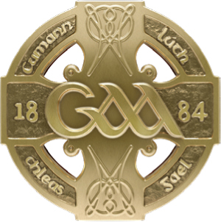
GAA GAA
Páirc an Chrócaigh Croke Park
Baile Átha Cliath 3 Dublin 3
Guthán +353 1 8658600 Telephone +353 1 8658600
Faics +353 1 8366420 Fax +353 1 8366420
www.gaa.ie www.gaa.ie

16ú Aibreán 2021

Do: Gach Rúnaí Chontae
Gach Runaí Chlub

Covid Update

A chara,

INFORMATION FOR CLUBS

Return to Training As you are aware non-contact training for underage teams in pods of 15 will be permitted from April 26th next in the 26 Counties. Our clubs in the North have returned in pods of 15 this week. “Underage teams” means any registered team at U-18 level or below.

Attached, please find the updated Guidelines for a Safe Return to Gaelic Games.

The key control measures remain completion of the online education module (which you can access here) and completion of the Health Questionnaire before each session (link to Health Questionnaire is here)

It is also important to remember that all indoor facilities must remain closed at this time, both North and South of the border.

Attendance at Training In general, only players and coaches of the relevant team should attend any training session. One Parent or Guardian per child (or per family if more than one child is attending from a particular family) is permitted to attend in a safeguarding /supervisory capacity involving any team in the U-18 or below age group, should they consider it necessary. However strict social distancing and public health guidelines should be adhered to at all times. In particular, it is important that parents do not congregate in groups before or after sessions, outside of what is permitted in current Government regulations.

Any person wishing to attend our underage training or games including coaches, parents, players and spectators shall be subject to the provisions of the Code of Behaviour (Underage).

Cont/d….

INFORMATION FOR COUNTIES

Return to Training Inter County Senior Hurling and Football panels are permitted to return to collective, full contact Training from Monday, April 19th. Attached is an updated set of Guidelines for inter-county teams which we would ask you to ensure is circulated to all members of your county panels and backroom teams.

A key message from our Covid Advisory Group is to avoid indoor gatherings wherever possible. For instance, it is permitted to use dressing rooms or hold meetings indoors, but we would strongly encourage you to explore alternatives or minimise usage as much as possible. Keeping the majority of your interactions outdoors is the key measure to follow if you wish to ensure the safety of players and support personnel.

U20/Minor/Academy Squad Training For clarity, Counties are asked to note that the current exemptions for underage club training and senior inter county teams DO NOT extend to U20, Minor or Academy squads; only players from a county’s Senior Panel are currently covered by the player injury scheme. Return to Training dates for underage inter county panels are contingent on further relaxation of Government restrictions – the GAA will advise further once any new information is made available.

Challenge Games The current relaxations to Government restrictions do not permit Challenge games to take place (unless between members of the same panel). We have been advised that this will be the position until May 4th at the earliest. We are seeking to have this position revisited as part of any further relaxation of Government restrictions and we will communicate further with Counties as soon as we have any additional information in this context.

Use of Gyms It is now permitted to open County owned gyms for members of the County Senior Hurling or Football panel as required. If gym work, or aspects of it, can be conducted outdoors, then risk of transmission of the virus is dramatically reduced. Ideally Gym activity indoors should be conducted on an individual basis or in very small groups.

Inter County players may also use their relevant Club Gym for individual training as long as they are following the advice in the Inter County Return to Training and Play document.

Finally, we would ask you to ensure that both Return to Play Documents and this cover note are circulated to all County Team Managers and backroom personnel at your earliest convenience.

Is muide, le meas,
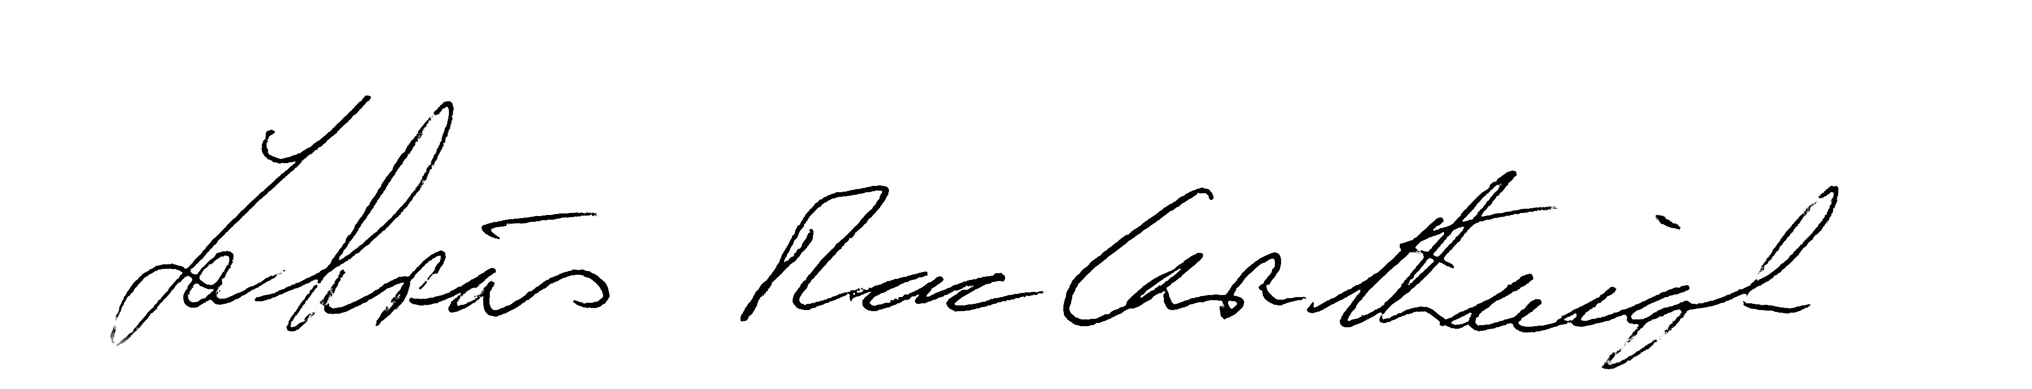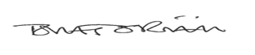

Labhrás Mac Carthaigh Tomás Ó Riain
Uachtarán Ard Stiúrthóir

