GLENARIFFE OISIN CLG CORONAVIRUS (COVID-19) RISK ASSESSMENT FORM BASED ON THE HSE “FIVE STEPS TO RISK ASSESSMENT”

Date: April 2021

L= Likelihood S= Severity RV= Risk value
RL= Risk Level, see Risk Assessment – Risk Matrix Below

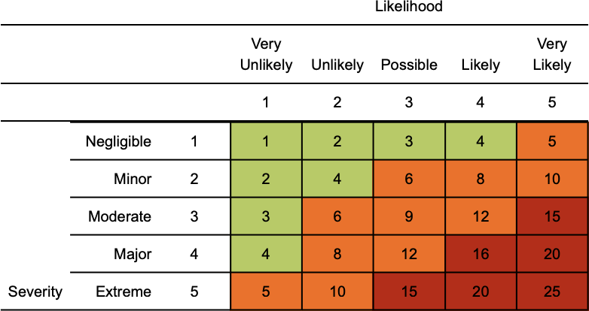

PERSON AT RISK | HAZARDS | EXISTING RISK CONTROLS | RISK |  |  | ADDITIONAL RISK CONTROLS | RESIDUAL RISK
 |  |  | L | S | RL |  | L | S | RL
Everyone attending our GAA grounds | Spread of Coronavirus (Covid- 19) within the workplace | Everyone to be reminded on a regular basis to wash their hands for 20 seconds with water and soap and the importance of proper drying with disposable towels. | 4 | 4 | 16 | To help reduce the spread of coronavirus (COVID-19) inform regularly everyone of the Government current public health advice.  Posters, leaflets and other materials are to be available for display.  Provide additional hand washing facilities with soap and water and suitable disposable hand towels for drying. | 3 | 4 | 12
 |  | Enforce social distancing at all times. |  |  |  | Provide additional bins to collect waste hand towels and ensure they bins are frequently emptied.
 |  | Remind everyone to catch coughs and sneezes in tissues – Follow Catch it, Bin it, Kill it and to avoid touching face, eyes, nose or mouth with unclean hands. |  |  |  | Provide additional hand sanitisers in any areas where washing facilities cannot be provided.  Ensure additional cleaning and disinfecting is carried out by team Covid supervisors
 |  | A regular supply of hand roll will be made available throughout the grounds. |  |  |  | Provide additional PPE as necessary
 |  | Encourage everyone to report any problems to club executive.

Everyone attending our GAA grounds | Exposure from others due to:  Anyone confirmed living with someone with a confirmed case of COVID-19.  Aware that the person has come into close contact (within 2 metres for 15 minutes or more) with a confirmed case of COVID-19.  Any person being advised by a public health agency that contact with a diagnosed case has occurred. | Club to create clear policy and procedure to deal with preventing exposure to Covid-19 to include current government guidance.  Ensure all mentors and Covid supervisors are aware of the content of policy and procedures and that they are followed.  Club to review any existing individual risk assessment (disability, young person, new or expectant mother) ) to ensure they are not at greater risk.  Club to create safe working distancing (maintaining 2 mtrs between staff).  Executive to review player medical declarations to ensure potentially vulnerable players are identified and a personal risk assessment is put in place.  Executive to ensure NHS guidelines for good hygiene are adopted throughout the club.  Suitable PPE is to be issued when required to provide respiratory and hand protection. | 4 | 4 | 16 | Executive and Covid supervisors to ensure internal communication channels and cascading of information is to be carried regularly to reassure and support players.  Executive and Covid supervisors to ensure that staff members are supported and that their wellbeing and mental health is supported at all times.  Executive,mentors,players.parents to be trained via GAA module, informed and instructed on the contents of this risk assessment and any associated procedures, checks that arise from it.  Addition things to consider could be:  - Create one-way system throughout our grounds  - Erect barriers /tape off areas  - Create pitch timesheet  - Create a testing regime  - Provide additional hand washing facilities.  - Allow regular breaks for hand washing.  - Ensure staff regularly wash hands.  - Provide separate bins for worn PPE.  - Increase cleaning regime to ensure common surfaces are cleaned more frequently.  - Provide additional suitable surface cleanser so everyone can clean as they come and go. | 3 | 4 | 12

PERSON AT RISK | HAZARDS | EXISTING RISK CONTROLS | RISK |  |  | ADDITIONAL RISK CONTROLS | RESIDUAL RISK
 |  |  | L | S | RL |  | L | S | RL
Everyone attending our GAA grounds | Suspect Covid-19 case at work | If anyone develops or reports a high temperature or  persistent cough while at at our grounds, players, supervisors/mentors are to isolate the player immediately.  Arrange the return to home to isolate.  Ensure area is cleaned down with a bleach solution (1-part bleach to 9 parts water). | 4 | 4 | 16 | Ensure player/parent is advised to follow Government guidelines on home isolation.  Covid supervisors to keep in regular contact with player and ensure they do not return to the grounds until their isolation has been completed.  Have player undertake a Covid-19 test before returning if possible. | 3 | 4 | 12
Everyone attending our GAA grounds | Exposure to Covid- 19 on public transport | Ensure social distance is maintained.  Wear suitable disposable gloves.  Consider wearing a suitable disposable face mask. | 4 | 4 | 16 | Ensure everyone in the club is kept informed of Government advice as it is updated. | 3 | 4 | 12

PERSON AT RISK | HAZARDS | EXISTING RISK CONTROLS | RISK |  |  | ADDITIONAL RISK CONTROLS | RESIDUAL RISK
 |  |  | L | S | RL |  | L | S | RL
Everyone attending our GAA grounds | General travel to/from our grounds | Where possible everyone should travel alone.  If not possible to travel alone the following should be considered: Share with the person and only have the minimum number in the vehicle.  Where possible maintain social distancing.  Wash hands for 20 secs regularly.  Wear appropriate PPE.  Clean vehicle regularly paying attention to handles and touched surfaces. | 4 | 4 | 16 | Create additional travel guidance if required  Ensure parking bays comply to social distance requirements.  Ensure everyone is kept informed of Government advice as it is updated. | 3 | 4 | 12

PERSON AT RISK | HAZARDS | EXISTING RISK CONTROLS | RISK |  |  | ADDITIONAL RISK CONTROLS | RESIDUAL RISK
 |  |  | L | S | RL |  | L | S | RL
Everyone attending our GAA grounds | General use of toilets, dugouts, changing facilities, showers | Restrict the number of people using toilet facilities at any one time.  Ensure all everyone wash or sanitise their hands before and after the use of toilets.  Break times to be staggered to reduce numbers congregating in areas. | 4 | 4 | 16 | Increase cleaning regimes for toilets, changing facilities, showers paying attention to door handles, locks, flushes.  Provide additional rubbish bins for hand towels and regularly empty them.  If changing areas, showers and drying rooms are required, consider increasing the number and size by providing temporary facilities.  Restrict numbers allowed in changing areas, showers and drying rooms at any time.  Where possible players should be asked to bring pre-prepared meals and refillable drinking bottles from home. | 3 | 4 | 12

PERSON AT RISK | HAZARDS | EXISTING RISK CONTROLS | RISK |  |  | ADDITIONAL RISK CONTROLS | RESIDUAL RISK
 |  |  | L | S | RL |  | L | S | RL
Everyone attending our GAA grounds | Site access and egress points | Stop all non-essential visitors.  Consider staggering start and finish times to reduce congestion and contact time.  Ensure social distancing is maintained at all times.  Use signage such as floor markings and remind everyone about hand washing.  Ensure all everyone washes their hands for 20secs when entering and leaving our grounds | 4 | 4 | 16 | Increase common area surfaces cleaning  Provide separate entry and exit points for players and officials. | 3 | 4 | 12

PERSON AT RISK | HAZARDS | EXISTING RISK CONTROLS | RISK |  |  | ADDITIONAL RISK CONTROLS | RESIDUAL RISK
 |  |  | L | S | RL |  | L | S | RL
Everyone attending our GAA grounds | First Aid and Fire | First aid and fire procedures are to be reviewed to ensure that sufficient cover can be maintained.  Executive are to ensure that sufficient fire aiders and fire wardens (if used) are available at all times during games and training. | 3 | 4 | 12 | Additional first aiders and fire warden will be to be considered to ensure sufficient cover.  Additional first aid equipment may be required therefore first aider must ensure sufficient kits are available.  All first aiders are to ensure they are up to date with the current NHS, HSE & Resuscitation Council guidance on providing emergency care under the current pandemic. | 2 | 4 | 8
Everyone attending our GAA grounds | Cleaning of facilities | Enhanced cleaning procedures are to be adopted to ensure that communal areas and touch points remain safe. | 4 | 4 | 16 | Covid supervisors to increase cleaning regime and ensure that additional cleaning of the following areas is carried out more frequently:  - Taps and washing facilities  - Toilet flush and seats  - Door handles and push plates  - Equipment controls  - Rubbish collection and storage points to be increased | 2 | 4 | 8

PERSON AT RISK | HAZARDS | EXISTING RISK CONTROLS | RISK |  |  | ADDITIONAL RISK CONTROLS | RESIDUAL RISK
 |  |  | L | S | RL |  | L | S | RL
All staff Cleaners | Cleaning of facilities | Enhanced cleaning procedures are to be adopted to ensure that communal areas and touch points remain clean and safe. | 4 | 4 | 16 | Executive to engage with Covid supervisors to increase cleaning regime and ensure that additional cleaning of the following areas is carried out more frequently:  - Taps and washing facilities  - Toilet flush and seats  - Door handles and push plates  - Equipment controls  - Rubbish collection and storage points to be increased | 2 | 4 | 8

Assessor-

Signed Gerry Cosgrove

Date Completed 28 April 2021

Date for next Review: weekly until end of playing season

